**Experiment 2: Internal CSS**

**Aim:** To make an attractive page using Internal Css.

**Tags Used:**

<style>

. -> is used for id

# ->is used for class

Background-color

Padding

Margin-left

**Implementation:**

**Output:**

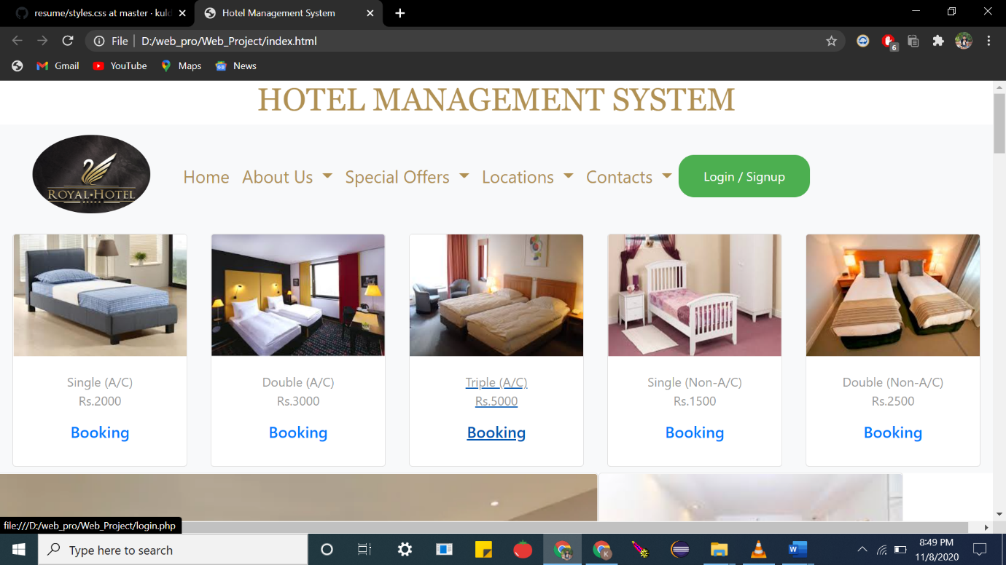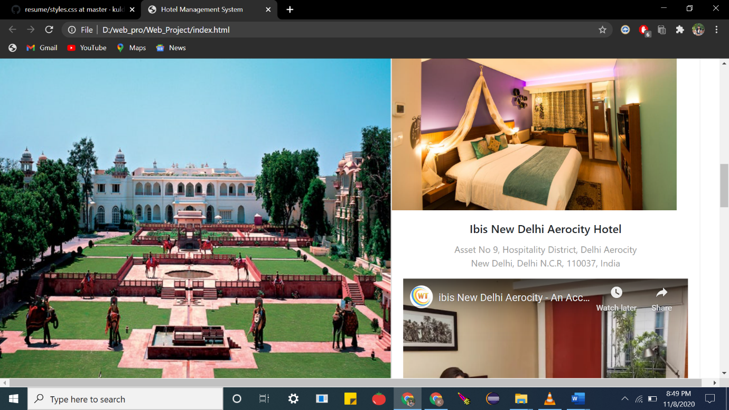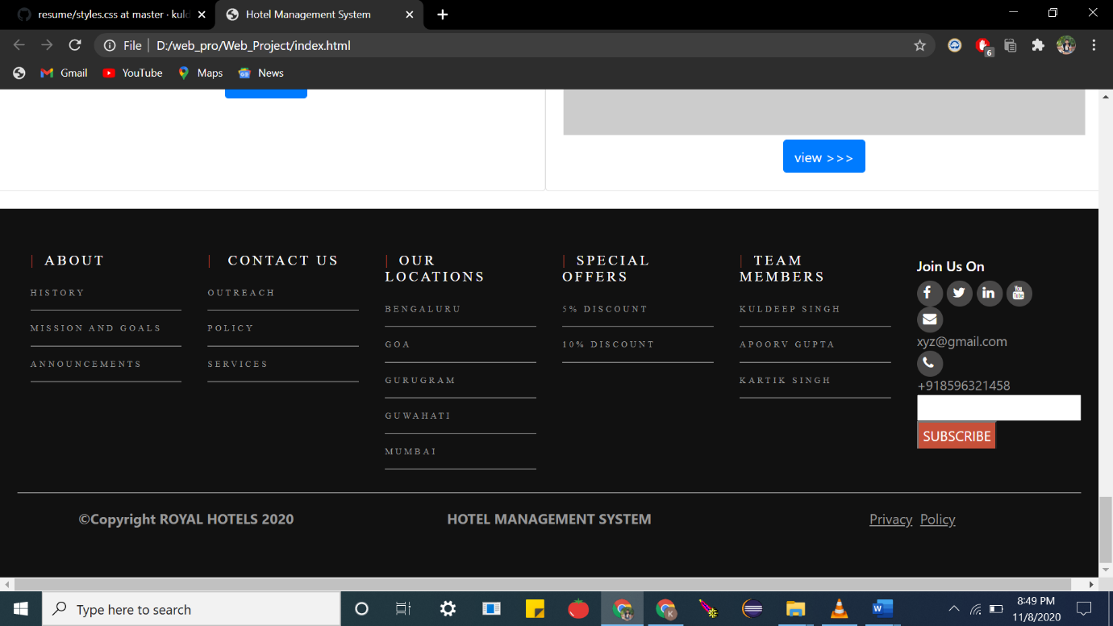

**Code:**

<link rel="stylesheet" href="https://stackpath.bootstrapcdn.com/bootstrap/4.5.2/css/bootstrap.min.css" integrity="sha384-JcKb8q3iqJ61gNV9KGb8thSsNjpSL0n8PARn9HuZOnIxN0hoP+VmmDGMN5t9UJ0Z" crossorigin="anonymous">

<script src="https://use.fontawesome.com/fdc4c76d34.js"></script>

<title>Home Page</title>

<style type="text/css">

. body

{

background-color:white;

}

#header-nav{

background-color:black;

width:100%;

height:100px;

}

.dropdown-menu{

background-color: darkgray;

}

.navbar-nav

{

padding-left: 100px;

}

.button {

background-color: #4CAF50; /* Green */

border: none;

border-radius: 20px;

color: white;

padding: 15px 32px;

text-align: center;

text-decoration: none;

display: inline-block;

font-size: 16px;

}

.footer-top{

background: #111;

color: white;

padding: 40px 20px;

text-decoration: none;

margin-top:20px;

}

.segment-one

{

font-family: Courgette;

color:#fff;

letter-spacing: 3px;

margin: 10px 0;

font-size: 10px;

text-transform: uppercase;

}

.segment-one h6:before

{

content: '|';

color:#c65039;

padding-right: 10px;

}

.segment-one ul

{

margin: 0;

padding:0;

list-style: none;

}

.segment-one ul li{

border-bottom: 1px solid rgba(255,255,255,0.5);

line-height: 40px;

}

.segment-one ul li a{

color: #999;

text-decoration: none;

}

.segment-two

{

font-family: Courgette;

color:#fff;

letter-spacing: 3px;

margin: 10px 0;

font-size: 10px;

text-transform: uppercase;

}

.segment-two h6:before

{

content: '|';

color:#c65039;

padding-right: 10px;

}

.segment-two ul

{

margin: 0;

padding:0;

list-style: none;

}

.segment-two ul li{

border-bottom: 1px solid rgba(255,255,255,0.5);

line-height: 40px;

}

.segment-two ul li a{

color: #999;

text-decoration: none;

}

.segment-three

{

font-family: Courgette;

color:#fff;

letter-spacing: 3px;

margin: 10px 0;

font-size: 10px;

text-transform: uppercase;

}

.segment-three h6:before

{

content: '|';

color:#c65039;

padding-right: 10px;

}

.segment-three ul

{

margin: 0;

padding:0;

list-style: none;

}

.segment-three ul li{

border-bottom: 1px solid rgba(255,255,255,0.5);

line-height: 40px;

}

.segment-three ul li a{

color: #999;

text-decoration: none;

}

.segment-four

{

font-family: Courgette;

color:#fff;

letter-spacing: 3px;

margin: 10px 0;

font-size: 10px;

text-transform: uppercase;

}

.segment-four h6:before

{

content: '|';

color:#c65039;

padding-right: 10px;

}

.segment-four ul

{

margin: 0;

padding:0;

list-style: none;

}

.segment-four ul li{

border-bottom: 1px solid rgba(255,255,255,0.5);

line-height: 40px;

}

.segment-four ul li a{

color: #999;

text-decoration: none;

}

.segment-five

{

font-family: Courgette;

color:#fff;

letter-spacing: 3px;

margin: 10px 0;

font-size: 10px;

text-transform: uppercase;

}

.segment-five h6:before

{

content: '|';

color:#c65039;

padding-right: 10px;

}

.segment-five ul

{

margin: 0;

padding:0;

list-style: none;

}

.segment-five ul li{

border-bottom: 1px solid rgba(255,255,255,0.5);

line-height: 40px;

}

.segment-five ul li a{

color: #999;

text-decoration: none;

}

.segment-six a

{

background: #494848;

width: 30px;

height:30px;

display: inline-block;

border-radius: 50%;

font-size: 15px;

text-decoration: none;

color: #999;

}

.segment-six a i

{

font-size: 15px;

color: #fff;

padding: 7px 7px;

}

.segment-six form input[type=submit]

{

background: #c65039;

border-bottom: none;

padding: 3px 5px;

color: #fff;

text-transform: uppercase;

}

.footer-bottom-text a,p

{

text-decoration: none;

color: #999;

}

@media only screen and (min-width: 768px) and (max-width: 991px)

{

.md-mb-30

{

margin-bottom: 30px;

}

}

@media only screen and (max-width: 766px){

.sm-mb-30

{

margin-bottom: 30px;

}

.footer-top

{

padding: 50px 0;

}

}style></head>

**Result:**The experiment was successfully completed.